FB50 -

Functionality
This is an SAP Enjoy transaction used to post GL documents. Using this transaction you can also post so-called cross-company code documents. For instance, if you want to post an entry that includes data relevant for company code 1000 to 5200:
- In the document header enter company code 1000
- In the relevant line item put code 5200, amount and other relevant data,
- In another line make posting for company code 1000.
In order to balance debit and credit the system will automatically generate two other line items to post to the clearing accounts in each of company codes.

Scenario

A user wants to post a GL document, using transaction FB50 (direct posting). Examples of this are journal entries.

Requirements
None

Menu Path | Accounting → Financial Accounting → General Ledger → Document Entry → FB50 - Enter G/L Account Document
Transaction Code | FB50
1. Double click on FB50 - Enter G/L Account Document.

Enter G/L account document: Company code 1000

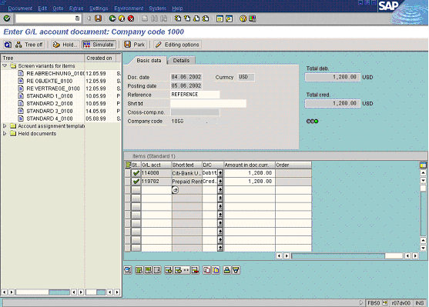

2. Update the following fields:

Field Name | Field Description | Values
Doc. date | Date of the document | Example: 040602
Currncy | Document currency | Example: USD
Reference | Document description | Example: refer
G/L acct | GL Account number | Example: 114000
D/C | Code identifying whether line item is a debit or a credit | Example: Debit
Amount doc.curr. | Amount to be posted for the line item | Example: 1200
G/L acct | GL Account number | Example: 119702
D/C | Code identifying whether line item is a debit or a credit | Example: Credi
Amount doc.curr. | Amount to be posted for the line item | Example: *

3. Click Enter .

Note: If you select an expense account, a cost object should be entered (cost center, profit center or internal order).

4. You can simulate document before posting. To do so, click Simulate Button .

Document Overview

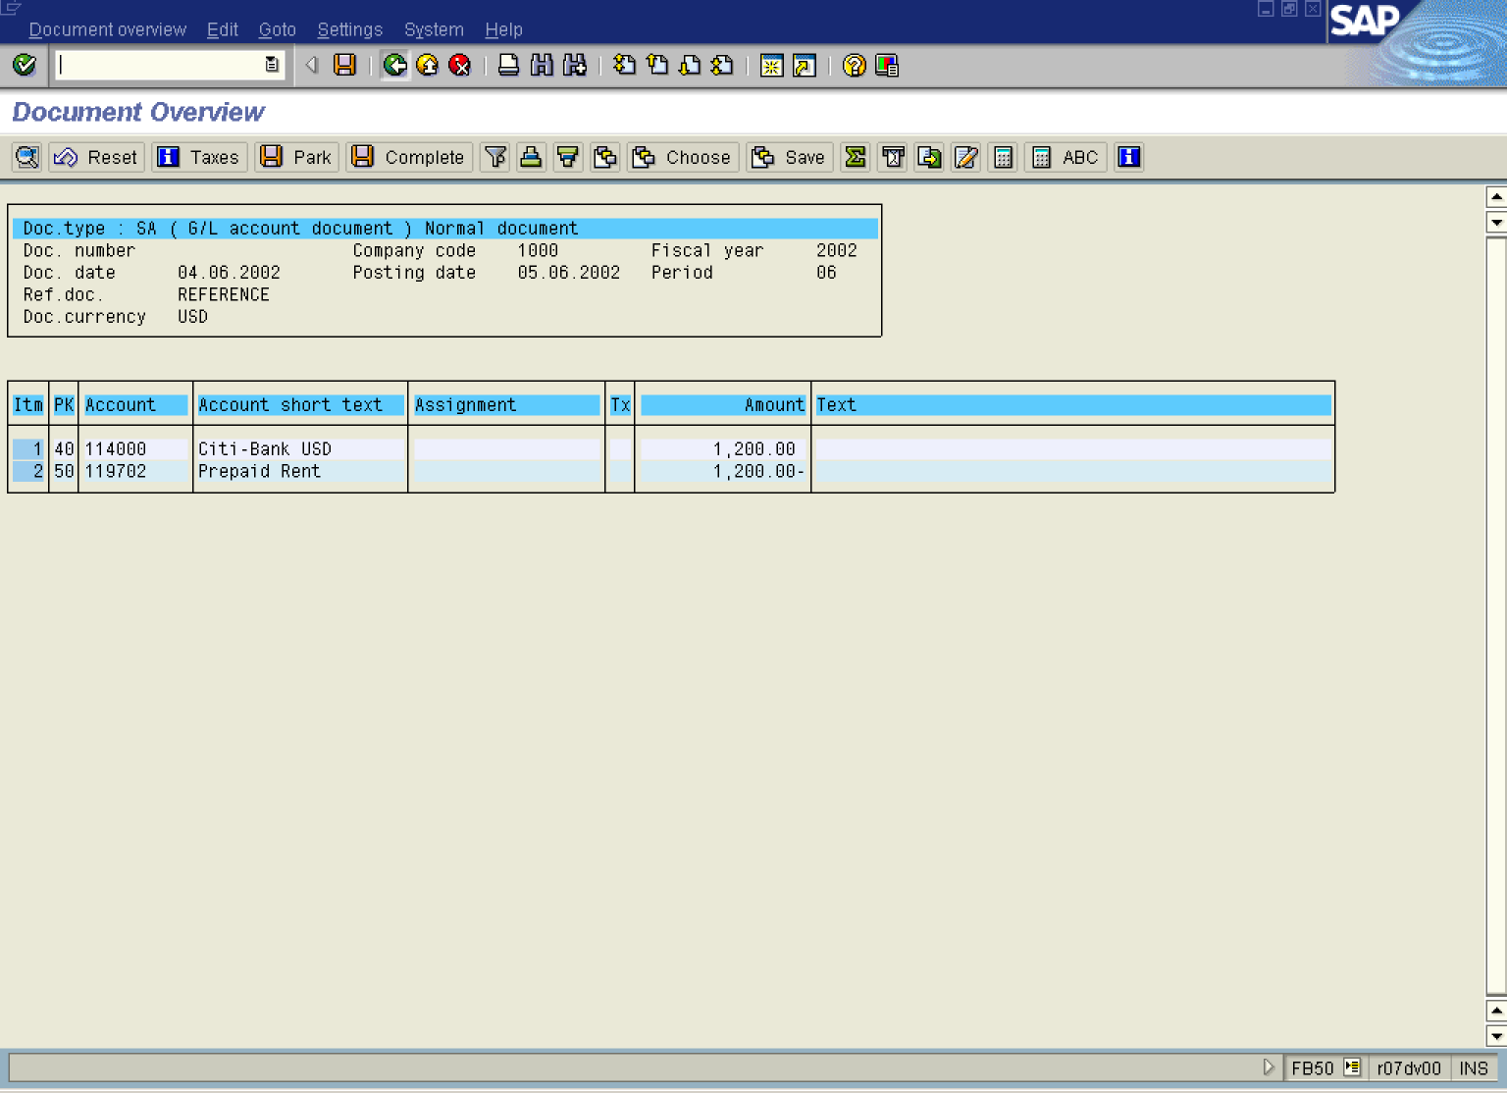
5. To post the document, click Save Button...

6. The message bar displays “Document number XXXXx has been posted in company code 5200”

